Wandong History Group Presents
The Mystery of Pretty Sally
Guest Speaker Grahame Thoms.

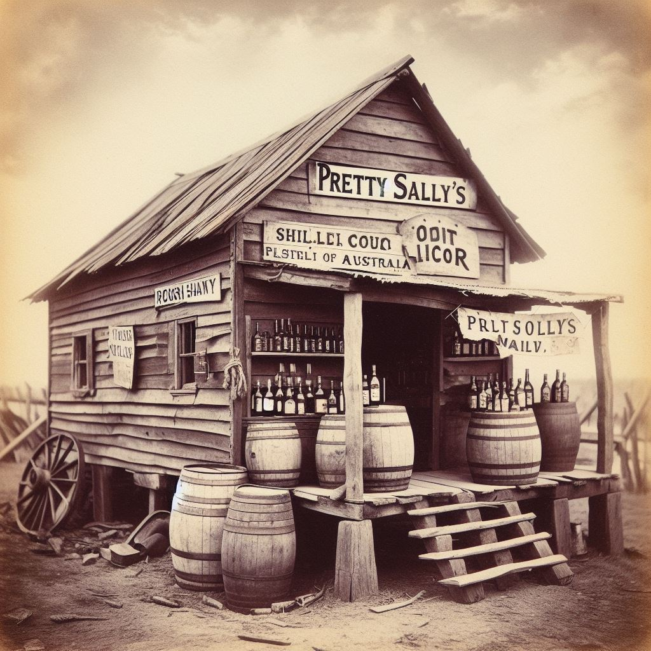
Ever wondered about Pretty Sally? Was she a real person, who was she, what is her story. Come along to hear Guest Speaker – Graham Thoms as he reveals an intriguing story about Pretty Sally and the treacherous hill that was named after her.

This event, presented by the Wandong History Group will be held at the Wandong Public Hall on Thursday, 30th May at 7.00pm.
Admission $5.00 Light Supper provided.
Join us to learn a fascinating history of a local icon.
RSVP: by 23/05/2024 wandonghistorygroup4@gmail.com
Ph 0432120736

